Alfred Abraham
CDS DX 799: Data Science Capstone
Dr. Von Korff
April 19th, 2026

Capstone Non-Technical Report
Executive Summary
Phishing is a form of cyber-attack that utilizes fraudulent emails, websites, text messages, or phone calls to deceive people into sharing sensitive information, downloading malware or engage in other activities that expose them to harm online. There is a need to effectively detect phishing attempts so that people can avoid falling for them. Over the past few semesters, I explored three phishing-related datasets to understand how machine learning could be used for phishing detection. Two of the datasets contained phishing and legitimate URLs as well as the characteristics associated with these URLs (i.e. url length, presence of ip address) while the last contained phishing and safe emails.
After exploring the structure of all three datasets, I utilized five classification models that fell into each of these categories: linear models, distance-based models, tree models, ensemble models, and probabilistic models. The linear model, Logistic Regression, was used as a baseline to compare the others against. While all models aside from the probabilistic Bernoulli Naïve Bayes model got results that met or exceeded the 80% success criteria, only the ensemble model, Random Forest, consistently got results that approximated or exceeded those of the baseline model on all three datasets. Therefore, I recommend using both this model and the Logistic Regression model for phishing detection. However, before deploying these models, it may be necessary to do preprocessing steps such as feature engineering and feature scaling as well as adjusting for the actual ratio of phishing and non-phishing samples in the real world. Once these steps are done, organizations and businesses are sure to improve their overall level of cybersecurity.
Introduction and Problem Definition
Computers and technology are an important part of life today. However, there are significant risks associated with their use. One such risk is online criminal activity, also known as cybercrime. Phishing is a major example of cybercrime that involves the use of fraudulent emails, text messages, or websites to trick people into sharing sensitive information (IBM). A typical phishing scam involves a hacker pretending to be someone that the victim trusts such as a colleague, boss, authority figure, or representative of a well-known brand to convince them to pay an invoice, open an attachment, click a link or do anything else that reveals sensitive information (IBM). According to IBM’s “Cost of a Data Breach” report, phishing is the most common data breach vector. In other words, it is the most tactic that cybercriminals use to access data they aren’t supposed to be able to access. Given this reality, there is a clear need to protect people, businesses, and organizations from phishing.
The objective of this project is to explore how machine learning classification models can be used to distinguish between phishing and legitimate URLs and emails. These models can be helpful because they can learn patterns from data that are not obvious to the human eye, enabling them to distinguish between phishing and legitimate URLs and emails based on these patterns. For this purpose, I used three datasets, two of which had URLs categorized as either phishing or legitimate and one of which had emails categorized as either phishing or safe. The metrics I used for this project were accuracy and the phishing f1 score. Accuracy is the total percentage of URLs or emails that are correctly classified while the phishing f1 score is an approximation of how well phishing URLs or emails in particular were classified. The success criteria I used was 80% or higher for both metrics.
Data Overview
The first dataset titled “Web page Phishing Detection Dataset” on Kaggle that has URLs categorized as either phishing or legitimate contains 11,430 rows, each representing one URL, and 87 extracted features (Kaggle). The dataset is well-balanced since for every phishing URL, there is one legitimate URL. Key features included in this dataset include length_url (URL length), length_hostname (hostname length) and ip (whether ip address is present). Since the URL text is included in this dataset, there is a significant ethical concern relating to privacy because URLs are usually linked to people and organizations. This has to be dropped during further analysis.
The second dataset titled “Web Page Phishing Dataset” on Kaggle has URLs categorized as either phishing or legitimate has 100,077 rows, each representing one URL, and 20 extracted features (Kaggle). This dataset is imbalanced since there are many more legitimate URLs (63,715) than phishing URLs (36,362). Key features in this dataset include url_length, n_dots (number of dots), and n_hypens (number of hypens). Unlike with the first dataset, the URL text is not included, making privacy less of a concern.
The titled “Phishing Email Detection” on Kaggle has 18,650 emails that are categorized as either phishing or safe. It has 16 missing values that need to be dropped. Just like the second URL dataset, it is imbalanced since safe emails (11,322) outnumber phishing emails (7,312). Since there are no extracted features, new features would have to be created using the TF-IDF technique. There is a privacy concern since email text, something that can contain personally identifying information, is included. This will need to be dropped from further analysis.
Data Cleaning, Preprocessing, and EDA
For the first phishing URL dataset, there was no need for data cleaning since no missing values were present. There was no need for preprocessing steps such as feature engineering (adding or modifying features) since there is more than enough information for machine learning models to learn from. When exploratory data analysis (EDA) was done, it was found that the average values for many of the features varied based on phishing or legitimate status. For instance, phishing URLs had a significantly larger average length_url value (~ 74.9) than legitimate URLs (~ 47.4). These differences can help machine learning models distinguish between the two categories.
For the second phishing URL dataset, there was also no need for data cleaning or preprocessing since no missing values were present and there was more than enough information for models to learn from. Just like with the first dataset, average values for many of the features varied based on phishing or legitimate status. For instance, phishing URLs had a length_url average value (~ 66.5) that was more than double that of the value for legitimate URLs (~ 23.6)..
For the phishing email dataset, data cleaning was needed since there were 16 missing values that had to be dropped. There was also a need for preprocessing since there were no extracted features machine learning models could learn from. Because of this, I used the Email Text column to generate new features with the TF-IDF technique, a natural language processing technique that calculates how frequently words occur in a text as well as how important they are. These new word-based features would later be used in machine learning models to distinguish between phishing and safe emails.
Modeling and Analysis
For all three datasets, I utilized five classification models, each of which fell into the following categories: linear models, distance-based models, probabilistic models, tree models, and ensemble models. These models were respectively as follows: Logistic Regression, K Nearest Neighbors (KNN), Bernoulli Naïve Bayes, Decision Tree, and Random Forest. Logistic Regression served as the baseline model since it is a standard binary (two-class) classification model. By using models belonging to these categories, I could find out which category performed best overall. To evaluate these models, I used the accuracy and the phishing f1 score metrics.
Before running these models on the datasets, I split the data into training and testing datasets. This was done to prevent the entire dataset from being for evaluation, reducing the potential of overfitting, the model fitting the data too well, in the process. I also did cross-validation, a technique that involves repeatedly splitting the data into training and validation folds, another way of ensuring that the entire dataset was not used for evaluation. In addition to these things, I did hyperparameter tuning via GridSearch to see if the results could be improved. This involved testing out particular combinations of model parameters to find out which resulted in the best metrics. To account for the fact that the second phishing URL dataset and the email dataset were imbalanced, I adjusted the parameters of the models to place more weight on phishing URLs and emails respectively. Since there were no extracted features originally in the email dataset, I utilized TF-IDF features and fed them to the models. To minimize both overfitting as well as computational resources, I set the upper limit of the number of features to 1000.
Results
After running the models on all three datasets, I tabulated the results and displayed them in column bar charts. For the first dataset, as shown below, all models met the 80% or higher success criteria with all of them aside from Bernoulli Naïve Bayes scoring in the 90 percent range. Twon models, KNN and Random Forest, beat the Logistic Regression baseline.
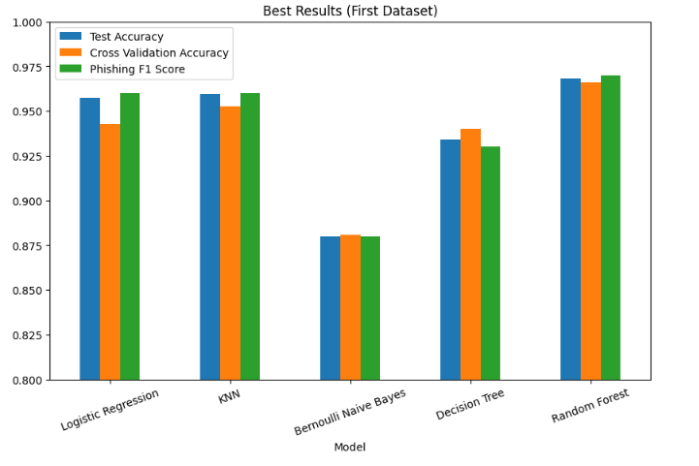
For the second dataset, as shown below, all models did worse than they did for the first one, getting less than 90% for all metrics. But aside from Bernoulli Naïve Bayes which had a phishing f1 score of 79%, they all met the 80% or higher success criteria. Given the failure of Bernoulli Naïve Bayes to meet the criteria, it is therefore ruled out for phishing detection.
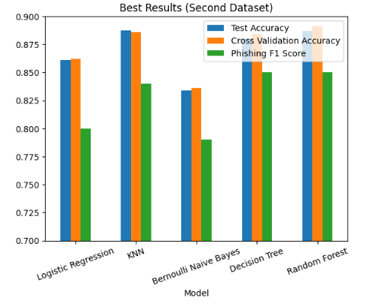
For the third dataset, as shown below, the results were more similar to those of the first dataset since all models aside from Bernoulli Naïve Bayes scored in the 90% range. However, unlike with the first dataset, KNN joined Decision Tree and Bernoulli Naïve Bayes in performing less than the Logistic Regression baseline while Random Forest got roughly the same results as the baseline. Since Random Forest is the only model that got results exceeding or at least approximating those of the Logistic Regression baseline, it along with Logistic Regression can be considered best suited for distinguishing between phishing and legitimate/safe URL and emails. This means that businesses and individuals will have an easier time recognizing phishing attempts and not falling for them when these models are used compared to when they are not used.
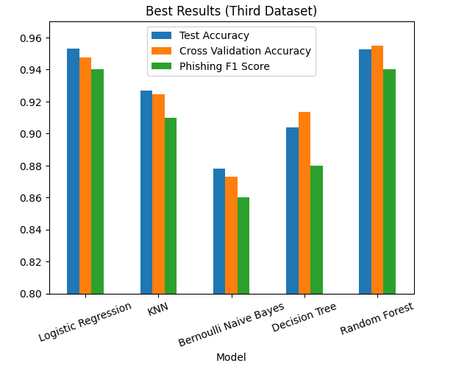
Recommendations
Based on these findings, it is recommended to use Random Forest and models like it alongside Logistic Regression for phishing detection given that this model performed better or approximately equal to the baseline for all three datasets. There are, however, a few things that should be accounted for. One of them is the necessity of appropriate preprocessing steps before using the models. These steps include feature scaling and feature engineering. Feature scaling involves using techniques such as standardization to mitigate the impact of differences in scale between features. This is needed for Logistic Regression but not so much for models such as Random Forest that are not so dependent on scale. Feature engineering involves the creation of new features that can better reflect the differences between phishing and non-phishing URLs and emails, making it easier for models to distinguish between them. The latter was especially needed for the email dataset since it contained no features that models could directly learn from. If one decides to use the email dataset or others like it, it would be necessary to experiment with various features that are created using TF-IDF or other methods. If one is using TF-IDF, one can vary parameters such as max_features to see how that impacts performance metrics, taking into account computational resources of course.
The other thing that should be considered is the ratio of phishing to non-phishing samples in the real world. This ratio could be very different from that of the three datasets. The last thing one should want is for a model to get a high accuracy score overall but fail to adequately predict phishing samples because of how infrequent they are. To address this, it will be necessary to adjust the parameters of the models to place extra weight on the minority class, usually phishing, or use other class balancing techniques such as the Synthetic Minority Over-sampling Technique (SMOTE). Overall, once all of these steps are taken, businesses and organizations will be able to more effectively detect phishing attempts, making them less vulnerable to this form of cybercrime and increasing their level of online security in the process.

AI Appendix
I did not use any AI tools for this assignment in order to ensure that everything reflects my work alone.

Works Cited
Kosinski, M. (2024, May 17). What is Phishing? IBM. https://www.ibm.com/think/topics/phishing
Web page Phishing Detection Dataset. Kaggle. https://www.kaggle.com/datasets/shashwatwork/web-page-phishing-detection-dataset
Phishing Email Detection. Kaggle. https://www.kaggle.com/datasets/subhajournal/phishingemails
Web Page Phishing Dataset. Kaggle. https://www.kaggle.com/datasets/danielfernandon/web-page-phishing-dataset

